**Dimension and Facts Basics**

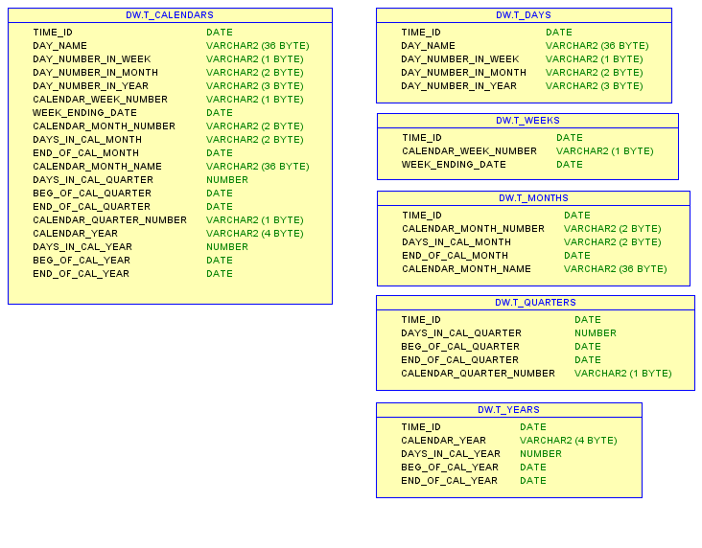

*/* Formatted on 7/22/2013 5:00:20 PM (QP5 v5.139.911.3011) */*

CREATE USER dw

IDENTIFIED BY 123456

DEFAULT TABLESPACE ts_dw_data_01;

GRANT CONNECT,RESOURCE TO dw;

ALTER USER dw QUOTA UNLIMITED ON TS_REFERENCES_DATA_01;

create table t_calendars as SELECT *-- create full year 2013*

TRUNC( sd + rn ) time_id,

TO_CHAR( sd + rn, 'fmDay' ) day_name,

TO_CHAR( sd + rn, 'D' ) day_number_in_week,

TO_CHAR( sd + rn, 'DD' ) day_number_in_month,

TO_CHAR( sd + rn, 'DDD' ) day_number_in_year,

TO_CHAR( sd + rn, 'W' ) calendar_week_number,

( CASE

WHEN TO_CHAR( sd + rn, 'D' ) IN ( 1, 2, 3, 4, 5, 6 ) THEN

NEXT_DAY( sd + rn, 'Saturday' )

ELSE

( sd + rn )

END ) week_ending_date,

TO_CHAR( sd + rn, 'MM' ) calendar_month_number,

TO_CHAR( LAST_DAY( sd + rn ), 'DD' ) days_in_cal_month,

LAST_DAY( sd + rn ) end_of_cal_month,

TO_CHAR( sd + rn, 'FMMonth' ) calendar_month_name,

( ( CASE

WHEN TO_CHAR( sd + rn, 'Q' ) = 1 THEN

TO_DATE( '03/31/' || TO_CHAR( sd + rn, 'YYYY' ), 'MM/DD/YYYY' )

WHEN TO_CHAR( sd + rn, 'Q' ) = 2 THEN

TO_DATE( '06/30/' || TO_CHAR( sd + rn, 'YYYY' ), 'MM/DD/YYYY' )

WHEN TO_CHAR( sd + rn, 'Q' ) = 3 THEN

TO_DATE( '09/30/' || TO_CHAR( sd + rn, 'YYYY' ), 'MM/DD/YYYY' )

WHEN TO_CHAR( sd + rn, 'Q' ) = 4 THEN

TO_DATE( '12/31/' || TO_CHAR( sd + rn, 'YYYY' ), 'MM/DD/YYYY' )

END ) - TRUNC( sd + rn, 'Q' ) + 1 ) days_in_cal_quarter,

TRUNC( sd + rn, 'Q' ) beg_of_cal_quarter,

( CASE

WHEN TO_CHAR( sd + rn, 'Q' ) = 1 THEN

TO_DATE( '03/31/' || TO_CHAR( sd + rn, 'YYYY' ), 'MM/DD/YYYY' )

WHEN TO_CHAR( sd + rn, 'Q' ) = 2 THEN

TO_DATE( '06/30/' || TO_CHAR( sd + rn, 'YYYY' ), 'MM/DD/YYYY' )

WHEN TO_CHAR( sd + rn, 'Q' ) = 3 THEN

TO_DATE( '09/30/' || TO_CHAR( sd + rn, 'YYYY' ), 'MM/DD/YYYY' )

WHEN TO_CHAR( sd + rn, 'Q' ) = 4 THEN

TO_DATE( '12/31/' || TO_CHAR( sd + rn, 'YYYY' ), 'MM/DD/YYYY' )

END ) end_of_cal_quarter,

TO_CHAR( sd + rn, 'Q' ) calendar_quarter_number,

TO_CHAR( sd + rn, 'YYYY' ) calendar_year,

( TO_DATE( '12/31/' || TO_CHAR( sd + rn, 'YYYY' ), 'MM/DD/YYYY' )

- TRUNC( sd + rn, 'YEAR' ) ) days_in_cal_year,

TRUNC( sd + rn, 'YEAR' ) beg_of_cal_year,

TO_DATE( '12/31/' || TO_CHAR( sd + rn, 'YYYY' ), 'MM/DD/YYYY' ) end_of_cal_year

FROM

(

SELECT

TO_DATE( '12/31/2012', 'MM/DD/YYYY' ) sd,

rownum rn

FROM dual

CONNECT BY level <= 365

)

;

*-- separated*

create table t_days as SELECT *-- day*

TRUNC( sd + rn ) time_id,

TO_CHAR( sd + rn, 'fmDay' ) day_name,

TO_CHAR( sd + rn, 'D' ) day_number_in_week,

TO_CHAR( sd + rn, 'DD' ) day_number_in_month,

TO_CHAR( sd + rn, 'DDD' ) day_number_in_year

FROM

(

SELECT

TO_DATE( '12/31/2012', 'MM/DD/YYYY' ) sd,

rownum rn

FROM dual

CONNECT BY level <= 365

)

;

create table t_weeks as SELECT *-- week*

TRUNC( sd + rn ) time_id,

TO_CHAR( sd + rn, 'W' ) calendar_week_number,

( CASE

WHEN TO_CHAR( sd + rn, 'D' ) IN ( 1, 2, 3, 4, 5, 6 ) THEN

NEXT_DAY( sd + rn, 'Saturday' )

ELSE

( sd + rn )

END ) week_ending_date

FROM

(

SELECT

TO_DATE( '12/31/2012', 'MM/DD/YYYY' ) sd,

rownum rn

FROM dual

CONNECT BY level <= 365

)

;

create table t_months as SELECT *-- month*

TRUNC( sd + rn ) time_id,

TO_CHAR( sd + rn, 'MM' ) calendar_month_number,

TO_CHAR( LAST_DAY( sd + rn ), 'DD' ) days_in_cal_month,

LAST_DAY( sd + rn ) end_of_cal_month,

TO_CHAR( sd + rn, 'FMMonth' ) calendar_month_name

FROM

(

SELECT

TO_DATE( '12/31/2012', 'MM/DD/YYYY' ) sd,

rownum rn

FROM dual

CONNECT BY level <= 365

)

;

create table t_quarters as SELECT *-- quarter*

TRUNC( sd + rn ) time_id,

( ( CASE

WHEN TO_CHAR( sd + rn, 'Q' ) = 1 THEN

TO_DATE( '03/31/' || TO_CHAR( sd + rn, 'YYYY' ), 'MM/DD/YYYY' )

WHEN TO_CHAR( sd + rn, 'Q' ) = 2 THEN

TO_DATE( '06/30/' || TO_CHAR( sd + rn, 'YYYY' ), 'MM/DD/YYYY' )

WHEN TO_CHAR( sd + rn, 'Q' ) = 3 THEN

TO_DATE( '09/30/' || TO_CHAR( sd + rn, 'YYYY' ), 'MM/DD/YYYY' )

WHEN TO_CHAR( sd + rn, 'Q' ) = 4 THEN

TO_DATE( '12/31/' || TO_CHAR( sd + rn, 'YYYY' ), 'MM/DD/YYYY' )

END ) - TRUNC( sd + rn, 'Q' ) + 1 ) days_in_cal_quarter,

TRUNC( sd + rn, 'Q' ) beg_of_cal_quarter,

( CASE

WHEN TO_CHAR( sd + rn, 'Q' ) = 1 THEN

TO_DATE( '03/31/' || TO_CHAR( sd + rn, 'YYYY' ), 'MM/DD/YYYY' )

WHEN TO_CHAR( sd + rn, 'Q' ) = 2 THEN

TO_DATE( '06/30/' || TO_CHAR( sd + rn, 'YYYY' ), 'MM/DD/YYYY' )

WHEN TO_CHAR( sd + rn, 'Q' ) = 3 THEN

TO_DATE( '09/30/' || TO_CHAR( sd + rn, 'YYYY' ), 'MM/DD/YYYY' )

WHEN TO_CHAR( sd + rn, 'Q' ) = 4 THEN

TO_DATE( '12/31/' || TO_CHAR( sd + rn, 'YYYY' ), 'MM/DD/YYYY' )

END ) end_of_cal_quarter,

TO_CHAR( sd + rn, 'Q' ) calendar_quarter_number

FROM

(

SELECT

TO_DATE( '12/31/2012', 'MM/DD/YYYY' ) sd,

rownum rn

FROM dual

CONNECT BY level <= 365

)

;

create table t_years as SELECT *-- year*

TRUNC( sd + rn ) time_id,

TO_CHAR( sd + rn, 'YYYY' ) calendar_year,

( TO_DATE( '12/31/' || TO_CHAR( sd + rn, 'YYYY' ), 'MM/DD/YYYY' )

- TRUNC( sd + rn, 'YEAR' ) ) days_in_cal_year,

TRUNC( sd + rn, 'YEAR' ) beg_of_cal_year,

TO_DATE( '12/31/' || TO_CHAR( sd + rn, 'YYYY' ), 'MM/DD/YYYY' ) end_of_cal_year

FROM

(

SELECT

TO_DATE( '12/31/2012', 'MM/DD/YYYY' ) sd,

rownum rn

FROM dual

CONNECT BY level <= 365

)

;